http://www.biologycorner.com/worksheets/interpreting_data.html
Name:______________________________________ Date:_______________
INTERPRETING ECOLOGICAL DATA
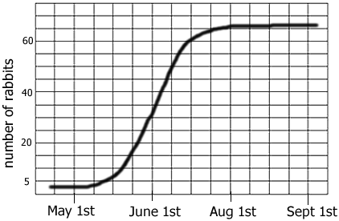
Graph 1: Rabbits Over Time
a. The graph shows a __________ growth curve.
b. The carrying capacity for rabbits is ______
c. During which month were the rabbits in exponential growth?

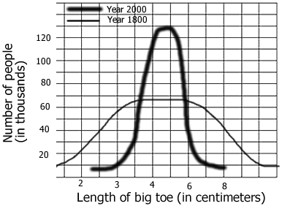
Graph 2: Average Toe Length
- In 1800, about how many people surveyed had a 3 cm toe? ______
- How many in 2000? _______
c. In 2000, what is the average toe length? ______ What is the average toe length in 1800 _______

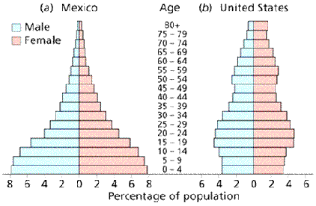
Graph 3: Mexico and US
a. In Mexico, what percentage of the population is between 0-4 years of age? _______ In the US? ______
b. Which population is growing the fastest? ________
c. Which age group has the smallest number in both countries? _____

Chart 4: Trapping Geese

Year | Geese Trapped | Number with Mark
1980 | 10 | 1
1981 | 15 | 1
1982 | 12 | 1
1983 | 8 | 0
1984 | 5 | 2
1985 | 10 | 1

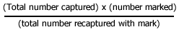
In order to estimate the population of geese in Northern Wisconsin, ecologists marked 10 geese and then released them back into the population. Over a 6 year period, geese were trapped and their numbers recorded.
a. Use the formula to calculate the estimated number of geese in the area studied? _____________
b. Supposing more of the geese found in the trap had the mark, would the estimated number of geese in the area be greater or lesser? _____

Chart 5: Mushroom Plots
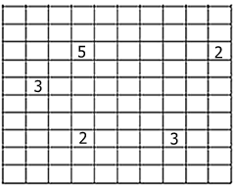
Another ecologist uses a different method to estimate the number of mushrooms in a forest. She plots a 10x10 area and randomly chooses 5 spots, where she counts the number of mushrooms in the plots and records them on the grid.
- Calculate the number of mushrooms in the forest based on the grid data – Show all your working

Chart 6: Snakes & Mice
Year | Snakes | Mice born | Mice died | Mice
1960 | 2 | 1000 | 200 | 600
1970 | 10 | 800 | 300 | 1400
1980 | 30 | 400 | 600 | 1300
1990 | 15 | 600 | 550 | 1350
2000 | 14 | 620 | 600 | 1370
2001 | 15 | 640 | 580 | 1430

The data shows populations of snake and mice found in an experimental field.
a. During which year was the mouse population at zero population growth? ______
b. What is the approximate carrying capacity for snakes? ______
c. What is the carrying capacity for mice? _____
d. What is the rate of growth (r) for mice during 1970? _____ During 1980? ______
Publisher: Biologycorner.com; follow on Google+
This work is licensed under a Creative Commons Attribution-NonCommercial 3.0 Unported License

